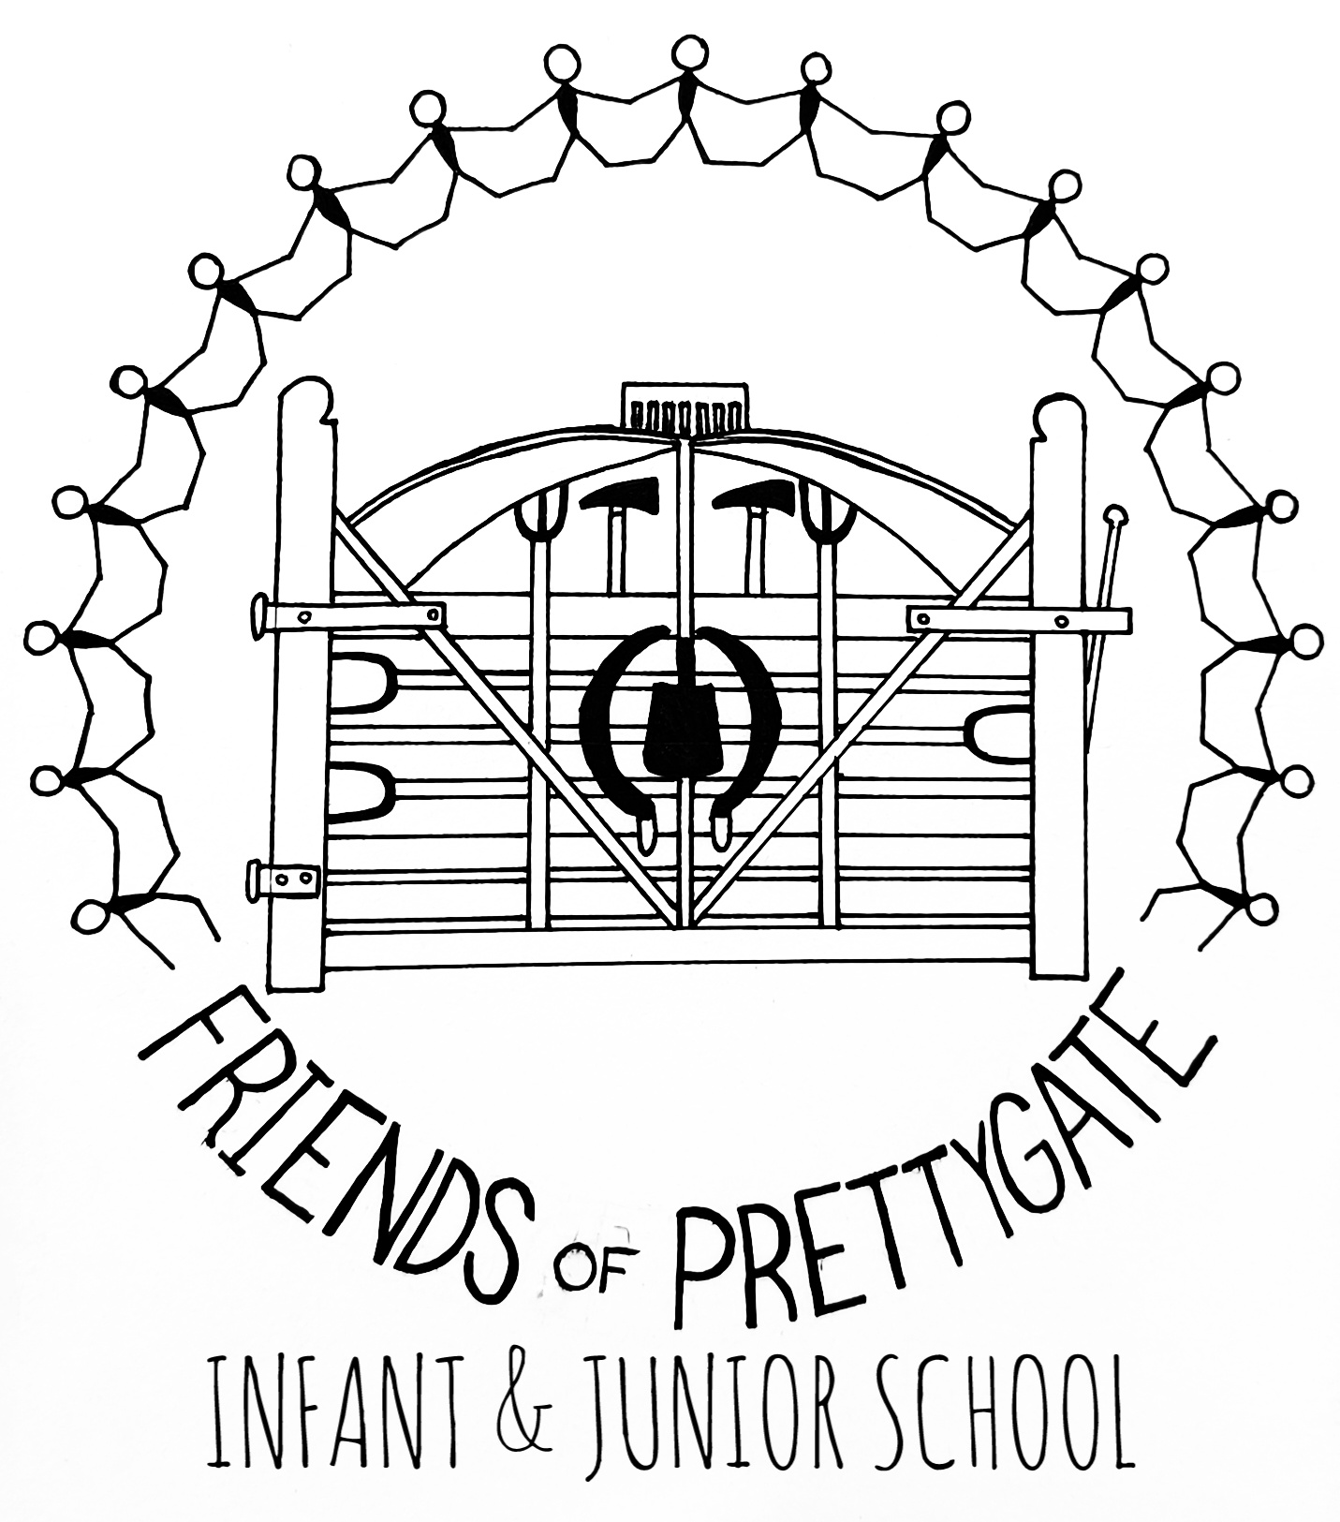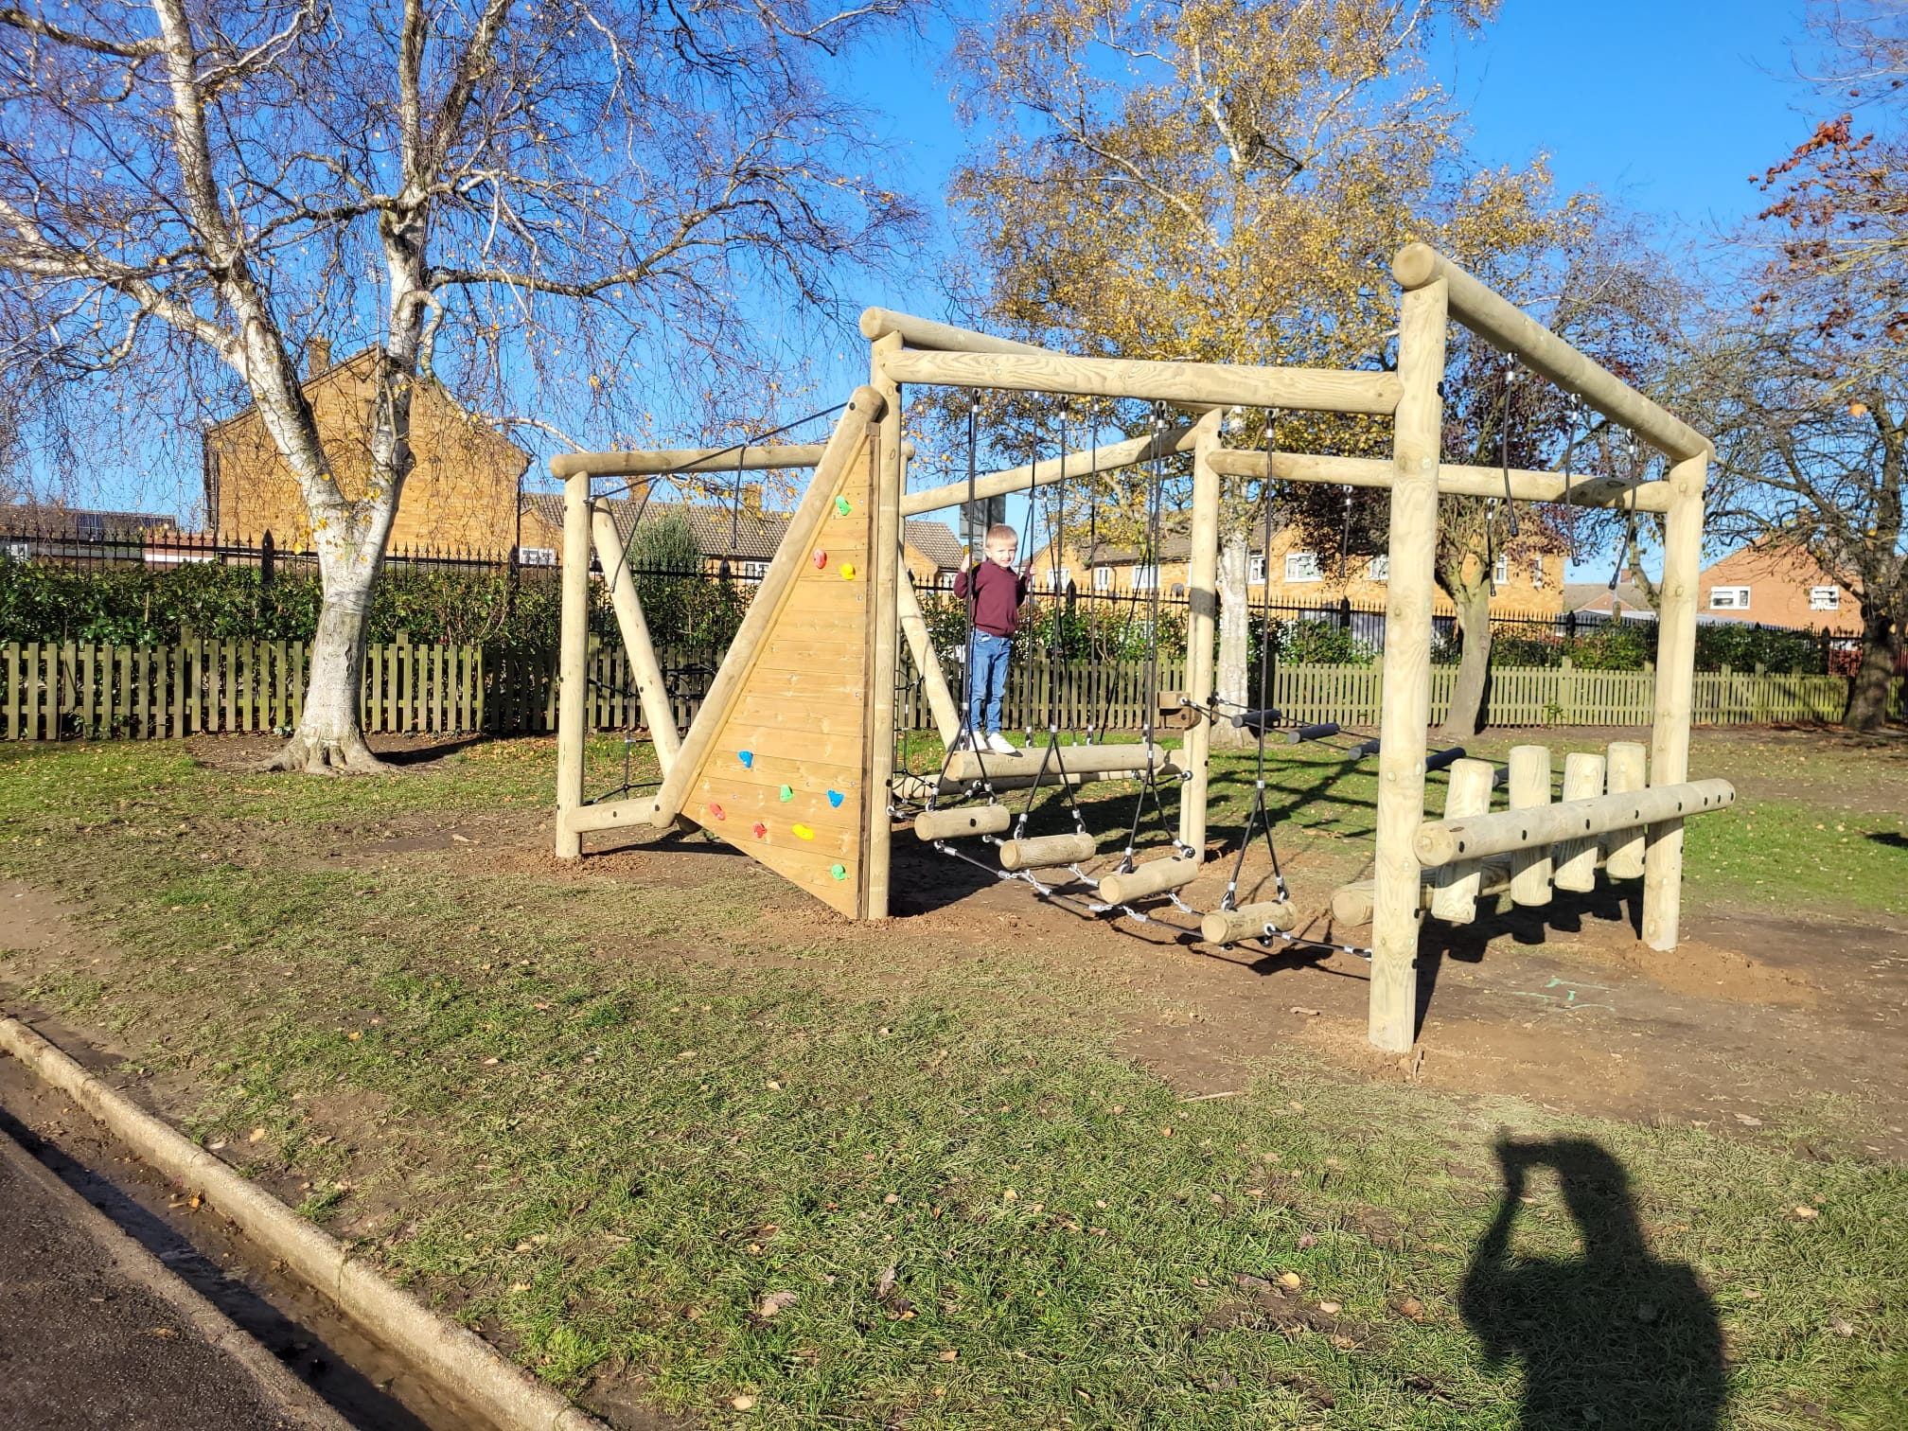

We are always happy for volunteers to get involved.  
Whether it’s helping out with an event or supporting in planning, or coming along to a meeting to help with ideas. We will be excited to see you.   
Without volunteers we couldn’t run the events and raise money to support the children of Prettygate schools.

Contact us via   
Facebook https://www.facebook.com/groups/friendsofprettygate

Email:  
friendsofprettygate@gmail.com

Website www.friendsofprettygate.co.uk

Phone : 07396700345

Who are we?

We are a group of parents who are trustees of the charity, Friends of Prettygate.

We have two Chairs -

Sarah Brown & Hollie Allen

Secretary - Jayne Rogers

Treasurer - Dom Bowers

We also have parents who regularly volunteer to help with events and planning. We are a community that supports and works with the school.

How to be involved

Charity no : 1199207

How do we raise money?

We run events through out the year. “Secret rooms” for mothers, fathers and Christmas. where you buy a ticket and your child gets to pick from a selection of pre-prepared wrapped gifts that they can then give to a loved one,

The Christmas fair, summer fete and Fireworks where fun can be had by the whole family while raising money. These and many more activities keep our calendar busy.

Where does the money get spent?

We support the school in a variety of different ways that enhance the enjoyment of school

We have purchased new play equipment for both the infant and junior school.

Helped by contributing towards the cost of taking all the children to sees the Panto at Christmas time. and many other things.

This is a two-part question, as a charity we raise money. We then use this to fund different things at the school

# What do we do?